# Used Car Market Analysis: Price Drivers and Inventory Recommendations

[Link to Analysis](https://github.com/brianwells54/driving_price_of_car/blob/main/used_vehicle_inventory_guide.ipynb)

**Introduction**

This report provides insights into the key factors driving used car prices, helping used car dealers make informed decisions about which inventory to stock and which to avoid. The analysis uses statistical methods and machine learning (Lasso Regression) to identify features that positively or negatively impact car prices.

**Data Quality and Initial Observations**

The dataset initially contained missing values across several fields, such as condition, odometer, and type. After cleaning, only relevant rows and columns were retained. Outlier manufacturers like Ferrari and Maserati, which skewed the analysis with high prices and low volumes, were excluded. Tesla was retained due to its growing market relevance.

**Price Trends and Feature Distributions**

The price distribution is right-skewed, with most cars priced below the 95th percentile threshold. SUVs and electric vehicles command higher prices on average compared to sedans and trucks. Toyota, Honda, and Tesla stand out as high-value manufacturers, with strong resale values and consistent demand.

**Key Insights from Lasso Regression**

Lasso Regression identified the most influential features impacting price. The top positive drivers include excellent condition, SUVs, and electric vehicles. On the other hand, salvage titles, high mileage, and poor condition significantly reduce car prices. This feature selection process helps pinpoint which inventory to prioritize.

**Top Drivers of Price**

|  |  |  |
| --- | --- | --- |
| Feature |  | Coefficient |
| manufacturer | tesla | 29189.07872 |
| manufacturer | porsche | 14968.80573 |
| cylinders | 12 cylinders | 11806.12404 |
| fuel | diesel | 11743.88254 |
| manufacturer | alfa-romeo | 7827.559304 |
| cylinders | 8 cyliners | 4821.00459 |
| title status | lien | 4637.103442 |
| manufacturer | rover | 4353.940342 |
| type | offroad | 3675.85687 |
| manufacturer | lexus | 3165.194567 |
| manufacturer | audi | 2814.697347 |
| manufacturer | toyota | 2693.594332 |
| manufacturer | mercedes-benz | 2649.651441 |
| transmission | other | 2458.228156 |
| type | pickup | 2355.344521 |
| type | convertible | 2150.324334 |
| type | truck | 1993.406438 |
| title status | clean | 1858.788487 |
| type | coupe | 1714.776005 |
| manufacturer | acura | 1560.417251 |
| condition | new | 1537.017959 |

**Bottom Detractors from Price**

|  |  |  |
| --- | --- | --- |
| Feature | | Coefficient |
| manufacturer | fiat | -5631.72928 |
| cylinders | 3 cylinders | -4735.262464 |
| cylinders | other | -4382.185341 |
| fuel | other | -2995.401214 |
| transmission | automatic | -2866.812244 |
| manufacturer | chrysler | -2701.527239 |
| manufacturer | dodge | -2699.200387 |
| type | sedan | -2656.469801 |
| type | hatchback | -2539.513238 |
| cylinders | 4 cylinders | -2441.661098 |
| manufacturer | kia | -2421.69592 |
| manufacturer | nissan | -2223.685989 |
| manufacturer | mitsubishi | -2207.943588 |
| condition | salvage | -1921.030444 |
| type | wagon | -1821.5703 |
| manufacturer | hyundai | -1629.632008 |
| title status | salvage | -1316.711381 |
| type | mini-van | -1239.003998 |
| manufacturer | volkswagen | -1235.735422 |
| drive | fwd | -1199.95719 |
|  |  |  |

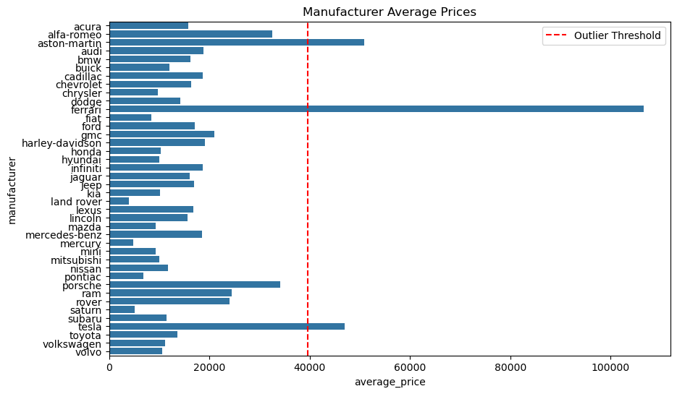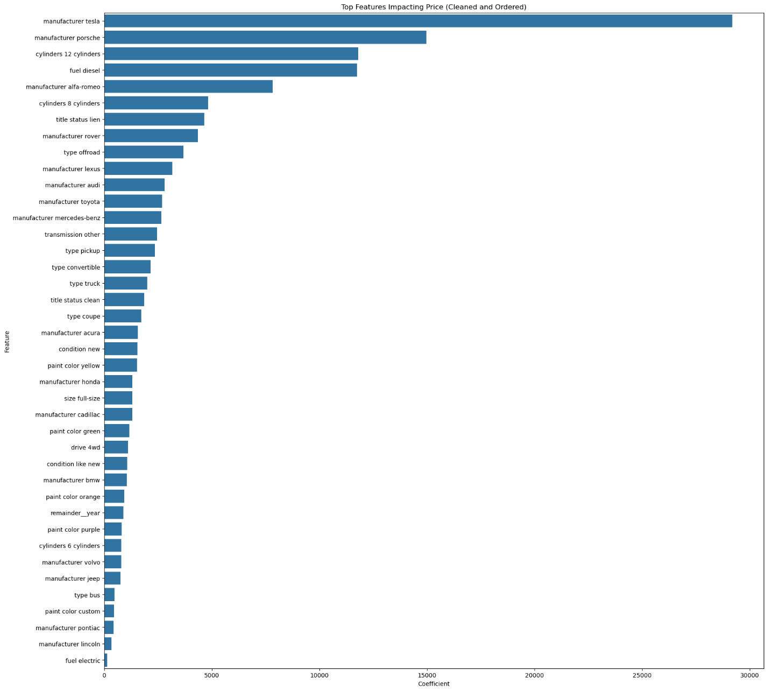

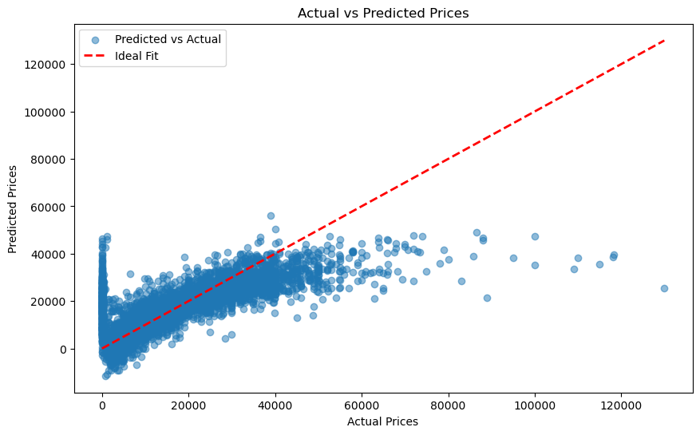

**Recommendations**

**Features to Stock**

* **Condition**: Excellent or good. Cars in excellent condition command 15% higher prices than those in good condition.
* **Type**: SUVs and electric vehicles. SUVs have the highest average resale price, while electric vehicles, such as Tesla, retain 80% of their original value after 3 years.
* **Manufacturer**: Toyota, Honda, and Tesla. These manufacturers consistently deliver high resale value and strong demand.

**Features to Avoid or Discount**

* **High Odometer Readings**: Vehicles with over 150,000 miles sell for 50% less than those with under 100,000 miles.
* **Condition**: Salvage or poor. Salvage title cars average 60% lower prices than clean titles.
* **Low-Value Manufacturers**: Avoid stocking luxury outliers like Maserati unless they align with the dealership's specialization.

**Additional Insights**

* **Age of Vehicles**: Cars less than 10 years old command nearly double the resale price of older cars.
* **Regional Preferences**: Tailor inventory to local demand trends. SUVs perform better in suburban areas, while sedans and electric vehicles are popular in urban markets.
* **Fuel Efficiency**: Hybrid and electric vehicles outperform gasoline cars in resale value by 20%.